CHAPTER 5 CARGO STOWAGE PLANNING

  - GENERAL
Cargo stowage planning should be performed by taking into account the cargo information and the precautions prescribed in this chapter and various data kept on board.
For the purpose of stowage planning in compliance with the provisions of IBC or BCH code, the following are prescribed in this chapter.
      - Flow chart for cargo stowage planning.
      - Precautions at each step specified in this flow-chart.
      - Loading manual (including trim and stability calculation).
      - Loading manual on the ship's survival stability in a damage condition required by IBC code.
      - Cargo suitability/resistance table for coated cargo tanks.
      - Restriction on previous cargoes prior to loading edible oil by NIOP and FOSFA. (Refer to the lists of restricted or acceptable previous cargoes appendix to this manual)
Master and responsible officers should well understand these booklets and information for proper cargo stowage planning.
In addition to above .1 to .6, the following must be considered for stowage planning:
        - The previous cargoes of the tank is suitable or not for quality specification of the next cargo on it's particularity.
        - As to the above a), hardness and difficulty of tank-cleaning to be taken into consideration in view of the kind and the condition of tank-coating.
Master should contact Shore Personnel in charge and discuss if he finds any problem or difficulties as a result of his stowage planning for the cargoes which Company has instructed to load.

  - FLOW-CHART
When planning an actual cargo stowage, the flow charts on the following two pages should be followed and stowage plans meeting the all check items in the flow-charts will result in compliance with the requirements of IBC or BCH code.

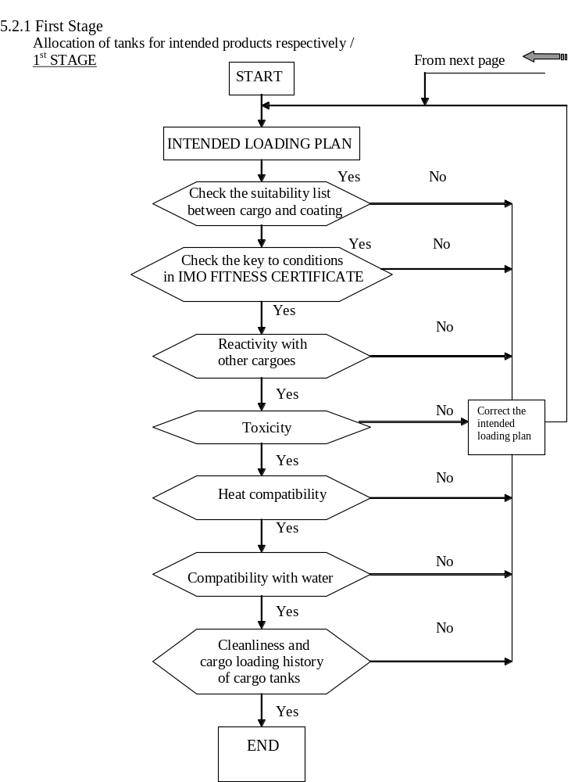

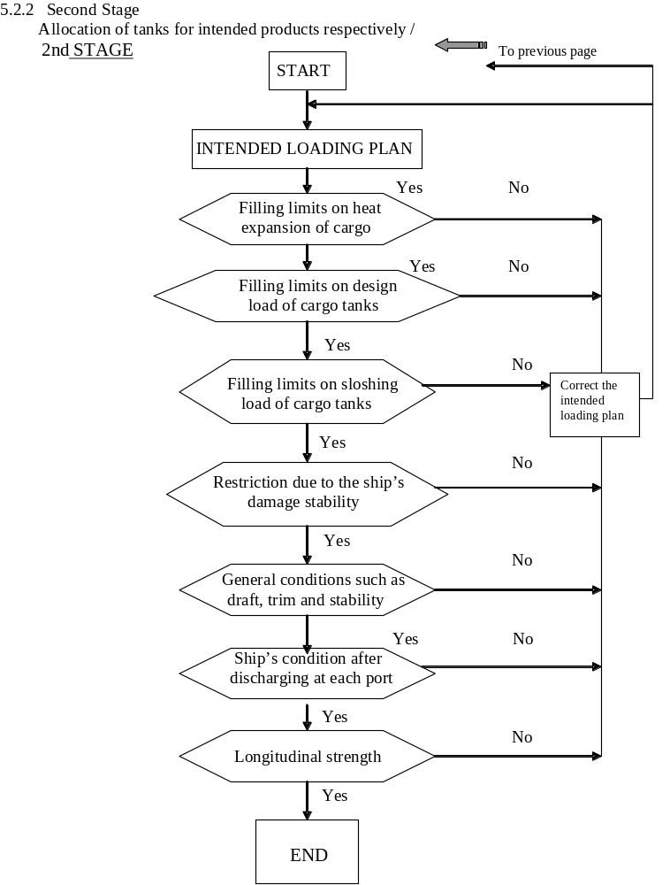

  - SEGREGATION
    - Reactivity with other cargoes
To prevent incompatible cargoes having hazardous reactivity each other from being stowed in adjacent cargo tanks.
Stowage should be planned after referring to and confirming the mutual reactivity amongst intended cargoes in Compatibility Chart (Figure 1) and Exceptions to the Chart (Appendix I) of U.S.A. 46CFR 150 Part A, concerned parts of which are attached to this manual as Appendix.
To check compatibility of two cargoes, the following procedure should be followed.
      - Both cargoes should be traced in which chemical group they belong.
[ Exp.: Cyclohexanone belongs Group 18, KETONES ]
      - Combination of cargo groups marked with "X" in the chart means not compatible each other, so the cargoes belonging to the groups of combination respectively should be segregated by not stowing in tanks adjacent to each other.
[Exp.: Caustic and Alcohol, Acetone and EDA (ethylene diamine), etc.]
      - There are some exceptions to the Compatibility Chart, which are shown in Exception to the Chart, the appendix I of the above regulation, which is also appendix to this manual.
      - If two cargoes are categorized in-group numbers between 30 throughout 43,the both cargoes are compatible; therefore the chart need not be referred.
[Exp. Toluene (Group 32, AROMATIC HYDROCARBONS) is compatible with CTC (Carbon tetrachloride) (Group 36, HALOGENATED HYDROCARBONS) ]
      - For categorizing chemicals, refer to Table I Alphabetical List of Cargoes of the above regulation, which is also appendix to this manual.
Note:
        - When Vessel intends to carry new cargoes, which are not covered by BCH/IBC code but not listed in chapter "intended cargo" in Vessel's Loading Operation Manual, Compatibility Chart including these new cargoes should be developed by authorities.
        - If the reactivity data of the loading cargo do not provide the necessary information, Master should consult Company for clarification.

    - Segregation from Other Tanks Loaded with Heated Cargoes
      - Heated cargoes should never be loaded adjacent to cargoes with self-reactivity such as polymerization, decomposition, thermal instability, etc. Excessive heating of self-reactive cargoes will shorten the life of the stabilizing inhibitor resulting in progress of self-reaction and finally deterioration in quality.
      - It is advisable that stowage of heated cargoes adjacent to tanks containing poisonous cargo is avoided to minimize the possible release of poisonous cargo vapour onto cargo area.
      - It is also advisable that a cargo requiring heating is not stowed adjacent to cargo tank that contains a cargo of low boiling point because the excessive evaporation of the cargo will result in cargo loss and possible vapour hazard in cargo area.
A difference of 10°C between the boiling point of the non-heated cargo and the maximum temperature of the heated cargo stowed in an adjacent tank should be sufficient as a safe margin in planning adjacent stowage.
This means; a heated cargo with maximum heating temperature less than 54.5°C may be stowed adjacent to ethanol (boiling point = 64.5°C ) when such stowage is inevitable.
Note: In consideration of the requirement of Para. 16.6.1 of IBC Code or equivalent of BCH Code, even if the heating temperature to be maintained is not so high to make the cargo in adjacent tank self-react, Master should not stow the heated cargo adjacent to a cargo subjected to the requirement.

    - Segregation of cargoes reactive with water
      - The data sheet indicates possible dangerous reaction between chemical and water or moisture (water), which causes damage to the quality of some cargoes and to tank coating.
      - Cargo tanks loaded with the following cargoes must be segregated from the tanks loaded with water such as fresh water for tank-cleaning or clean sea water as gale ballast as any leakage of water into the cargoes may cause hydrolysis of the cargoes resulting in increased corrosivity.
Acetonitrile, Carbon tetrachloride, Dichloroethyl ether, Ethyl acrylate, Ethylene dichloride, Vinyl acetate, etc.
      - Those cargo tanks to be loaded with the cargoes reactive dangerously with water should be completely cleaned and dried to eliminate any residual water.
Note: Refer to Para. 15.16.2of IBC Code or equivalent of BCH Code for carriage of cargoes reactive with water.

    - Co-mingling non-compatible cargoes in slop tanks & drip trays
      - Non-compatible cargoes are not to be co-mingled in same compartment.
      - The cargo operation planning is to be considered with respect to the dangers concerned with non-compatible cargoes.
  - LOADING LIMITATION OF CARGO
    - Filling Limits for Cargo Thermal Expansion
      - Tanks carrying liquids at ambient temperature should be so loaded as to avoid the tank becoming full with liquid due to thermal expansion during the voyage with due regard to the highest temperature which the cargo may reach.
      - The highest temperature is to be determined with due consideration to the period, season, route, etc. of the voyage and cargo loading condition in each case.
      - "Liquid-full" means a tank to be full of cargo up to the openings of tank top i.e. vent pipes at the highest temperature.
      - There should be a certain volume of remaining vacant space in the cargo tanks above the cargo surface to accept the thermal expansion of the cargo after loading.
      - Trim of Vessel in expected loaded conditions is to be taken into consideration. For applying the foresaid requirement, an error of measurement of the liquid level is to be taken account.
      - The cargo tanks can be loaded up to a liquid level corresponding to the maximum filling ratio obtained from the following formula.
Max. Filling ratio (% full) = 100 (1 - R x T) - S
where;
R : Coefficient of cubical expansion per °c (see the data sheet)
T : Expected maximum temperature rise (°c)
S : Safety margin, usually 2% of capacity

    - Filling Limits for Cargo Tank Design Specific Gravity
In addition to the precautions in the proceeding Para. 5.4.1 for determining the filling limits, it is necessary to take into account the correction between the design specific gravity (DSG) of the cargo tanks and the specific gravity (SG) of the cargo loaded.
Max. Filling limit can be calculated by the following formula.
Max. Filling ratio (% full) = DSG/SG x 100
Example of calculation:
DSG = 1.4
SG= 1.48 (Chloroform)
Then max. Filling ratio is 1.4/1.48 x 100 = 94.6 %

    - Filling Limits for Sloshing Strength of Cargo tank
      - In general, partial loading between 20% and 80% of filling ratio is prohibited to avoid an excessive sloshing load on the tank structure.
      - However, if partial loading is involved in the intended plan, cargoes should be loaded to the extent of a safe loading percentages as determined after referring to the sloshing calculation shown on Vessel's Loading Operation Manual.
      - Greater the SG, the effect of sloshing on Vessel's structure bigger.

  - DAMAGE STABILITY CHARACTERISTICS
      - The damage stability characteristics of Vessel must be understood, and there must be evidence that the damage stability has been evaluated for the present and previous voyages.
      - When chemicals specified in BCH/IBC code are about to be loaded, it must be confirmed that the intended stowage plan has a sufficient survival capability in damaged condition as per the requirement of the code, and only the plan having sufficient survival capacity can be permitted.
      - The damage stability calculation is based on the Chapter 2 "Ship Survival Capability and Location of Cargo Tanks" of IBC Code or equivalent of BCH Code. For detailed method of calculation, refer to Vessel's Damage Stability Manual or the like kept on board.
      - In the manual, assessment of damage stability by the allowable maximum KG method is generally used, which enables Master to assess the damage stability easily.

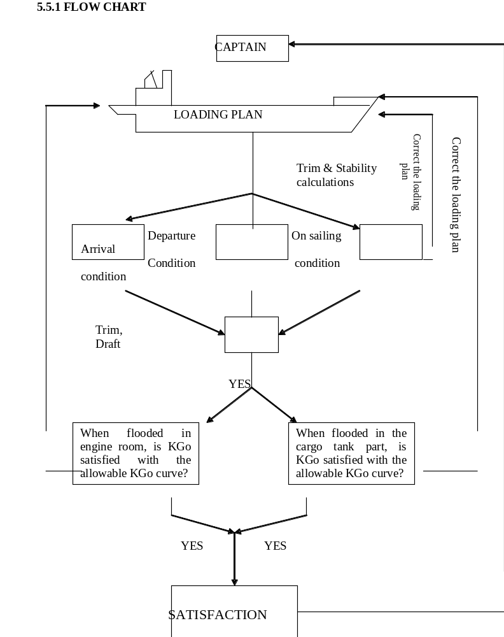

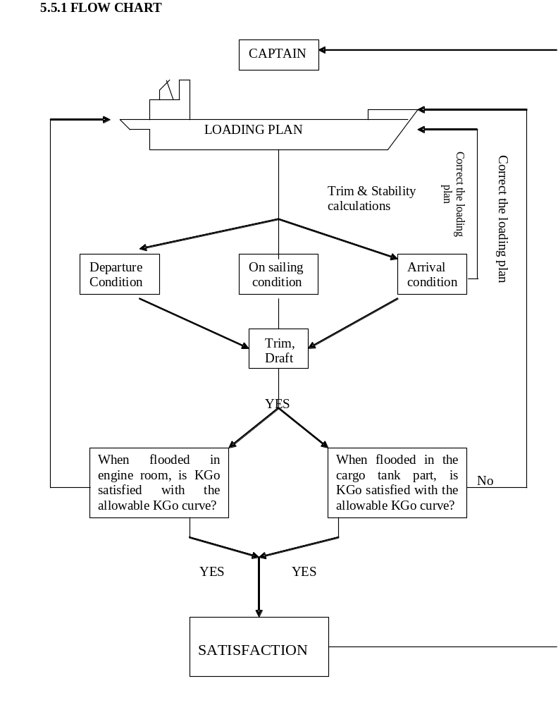

  - STABILITY AND STRESS
    - General
      - In accordance with the relevant regulations, Vessel has been supplied with a booklet titled Loading and Stability Information Booklet or the like which contains various information and data necessary for calculation of her stability and stress on her hull for Vessel's safe navigation and adequate stowage of cargo.
      - Vessel should keep evidence that a stress and stability calculation has been made for the current voyage and cargo operation. This may be in either written form or may be stored in the computer. There should also be evidence that this procedure is in common use.

    - Notice on Concerning Stability
      - The stability of Vessel under actual service conditions must be maintained to comply with the requirements of IMO A.167 (ES.IV) and A.562 (14).
      - Transverse metacentric height GoM should be greater than required minimum permissible GoM.
      - As the spaces of the forecastle and poop decks have been taken into consideration in the stability calculation, weather tight doors, oil tight hatches, small hatches or other openings should be closed tightly before Vessel sails.

    - Longitudinal Strength and Allowable Value
It is required to keep the longitudinal bending moment (B.M.) and shearing force (S.F.) at any parts of hull within the allowable limit. In order to keep B.M. and S.F. within allowable limit, care should be taken so as to avoid excessive stresses by the effect of wave while Vessel is navigating on a rough sea.

  - ANGLE OF HEEL
      - Vessels are not to proceed to sea unless in an upright condition.
Except in special circumstances, movements within port limits should be carried out with Vessel in an upright condition.
      - Discretion is left to Master to decide these circumstances with due consideration to the effect on the maneuvering characteristics of Vessel in the listed condition increase in draft and effect on structures when getting alongside.

  - RESTRICTION OF LOADING EDIBLE OILS
      - The associations of traders and producers of edible oils such as the "NIOP" in North America and "FOSFA" in Europe have acute concern with the necessity to protect health of the consumers against hazardous substances likely to contaminate their products during transportation.
      - The shippers/consignees belonging to NIOP and FOSFA restrict loading of their edible oils into cargo tanks which have carried certain hazardous cargoes previously by the rules of "NIOP/FOSFA".
Therefore, edible oils owned by the shippers and/or consignees must be loaded in the tanks which satisfy the rules. The carriers are required to plan the stowage of such edible oils as per the requirements of the rules.
Note: NIOP (The National Institute of Oilseed Products)
FOSFA (Federation of Oils, Seeds and Fats Association)

